# ADC Filters

## Engine and sensor characteristics

Calculations below are based on sensor characteristics, an engine that has slower response will have a slower MAP change and can take more filtering. A ‘standard’ Bosch MAP sensor has a TC of 1ms, a faster BOSH senspr has a Tc of 0.1ms, this may be required on a high performance vehicle.

Similarly an engine with a larger thermal mass can also take more filtering on the CTS.

Logging the ECU datastream can be used to determine the optimium filter requirements.

*Insert vehicle log.*

## ADC input channels

### TPS

As a guide an ETC has T = 80ms approx = 12.5Hz

12.5Hz * 5 = 62.5Hz, if we say 50Hz bandwidth then we need to sample at 100Hz minimum.

Oversampling * 8 = 800Hz

### IAT

# Bosch motorsports NTC M12-L

Bosch Motorsport CTS tau = <10s

Range = -40C to +130C = 170.

170 *.63 = 107.1

10/214 = 47ms for 0.5 degrees change = 21.5Hz

Could use 100Hz bandwidth/200Hz sample rate

### CTS

Bosch Motorsport CTS tau = <15s

Range = -40C to +130C = 170.

170 *.63 = 107.1

15/214 = 70ms for 0.5 degrees change = 15Hz

Could use 100Hz bandwidth/200Hz sample rate.

### MAP

Bosch Motorsport parts vary from 01ms to 1ms response, older parts are 1ms

Use 1kHz bandwidth/2kHz sampling for current application.

### Battery Voltage

For battery voltage we need to measure longer term trends, injector time constant will filter out fast transients so we need to avoid measuring them, to ensure that the battery voltage measurement tracks the injector voltage we could design the filter to have the same time constant as the injector.  
Injectors are approx. 15mH, 12Ohms so tau = L/R = 1ms approx.

Use 1kHz bandwidth/2kHz sampling

Note: 33920-70E10 = 37.5Hz, could sample at 100Hz, this may be because of a slow processor.

## Lambda

The 14point7 ADV wideband sensor claims to have the fastest response at 7ms/142hz.

A filter bandwidth of 150Hz and a sample rate of 333Hz would be simplest to achieve.

### CPU temperature

CPU temperature is used on more advanced ECUs to optimise the ADC slope and gain compensation.

## Knock

Knock is handled natively by the SPC572L using the SDADC and hardware decimation filters so it is not included here.

## Digital Filtering

The max required sample rate is 2kHz so 8* oversampling gives 16kHz

Six channels means an ADC sample rate of 16kHz * 7 = 112kHz.

If the ADC interrupts every five conversions then

MAP and Battery are sampled every interrupt

Lambda is sampled every 3 interrupts

TPS, IAT and CTS and CPU temp are sampled every 10 interrupts

The result of the previous two samples is used to predict the next sample, the next sample is then compared to the predicted value and if it is outside a specified tolerance then it is discarded as obvious noise and substituted with the predicted value.

The filtered input is then passed to an 8-tap and the integrator is then sampled from the main code at the appropriate frequency.

# ADC Conversion Speed

## Tconv

tconv = tprechg + tsample + teval

## Tprechg

Precharge is not used

## Tsample

Assume Tprechg is at least 10 times the time constant of the sample and hold stage, if the input resistance is 6k1 maximum then:

T = 6k1*8p5

= 520ns approx.

Set the sample period to 10 times the time constant = 0.5us but the datsheet states 0.833us minimum for 10-bit resolution so just call it 1us.

## Teval

teval = 10 * tck (for 10-bit conversion)

If the ADC is run at approx 100kHz max t = 10us  
 so the ADC clk must run at approx. 1.1MHz

With a 16MHz clock 1MHz is the nearest practical implementation.

Note: the datasheet specifies Fadc minimum as 7.5MHz

# Analogue Filter design

SPC572L ADC maximum input resistance

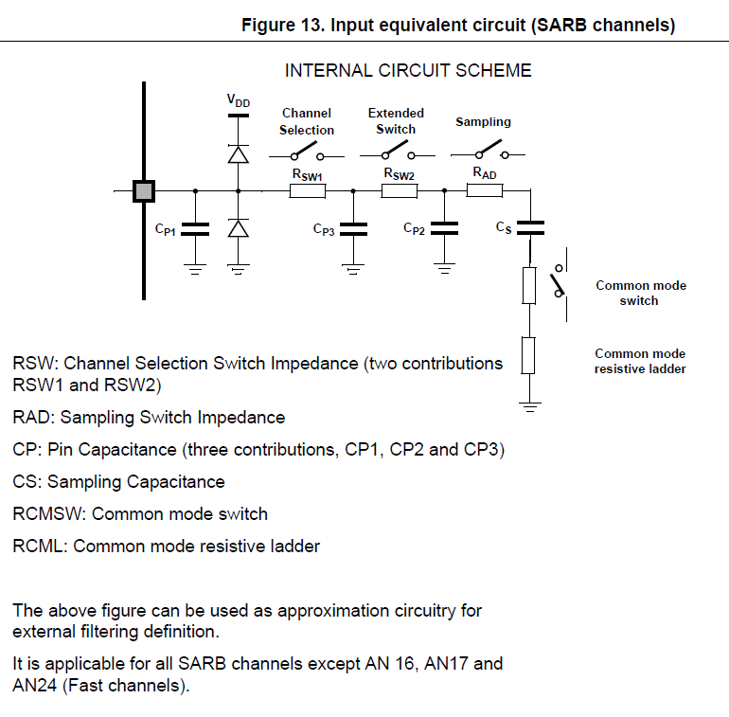

## Filter chain for a 1ms sensor



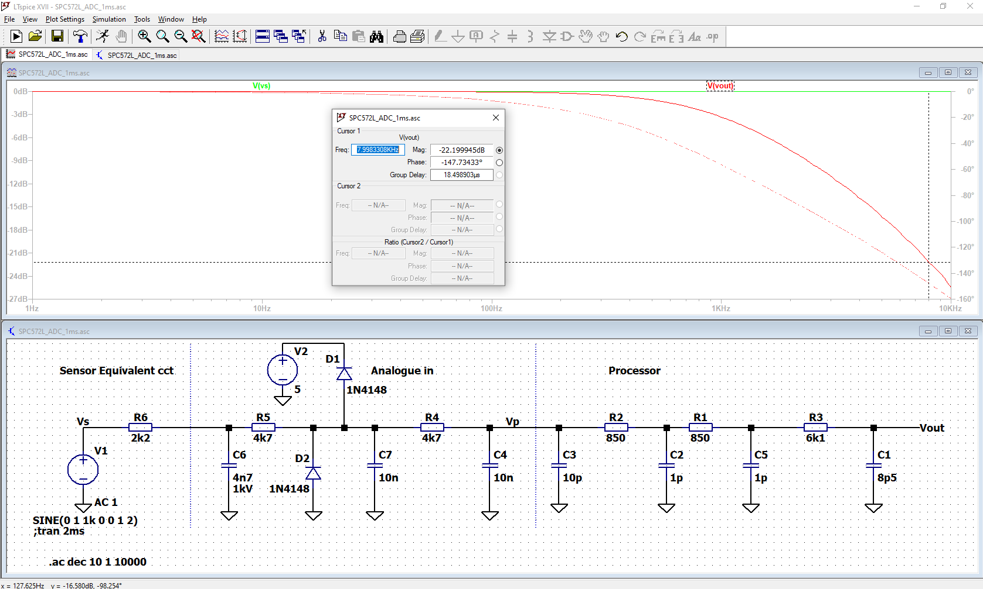

At 1kHz bandwidth the gain is reduced by approx. 22dB at the first possible alias frequency.

The anti-aliasing cap, C4, has a capacitance approx. 100 times the total sampling capacitance. If we ignoring the current flowing through R4 and just calculate the approximate voltage drop in C4 caused by it discharging into the ADC then:

At 5V, Q = CV = 5*10.5pF = 52.5pC

At 10nF, V = Q/C = 52.5pC/10n = 5.25mV

So the charge for the sample and hold capacitor can be almost wholly supplied from C4 which means that Tsample can made = (6k1 * 8p5) = 50ns with less than 0.1% error.

Note: the above illustrates the maths, its easier to just divide the voltage by the ratio, ie 5V/1000 = 0.001 or 0.1%.

Note: need to check inrush current

## Filter chain for a 10ms sensor

To create a filter chain for a 10ms filter C7 and C4 are incresed to 100nF.

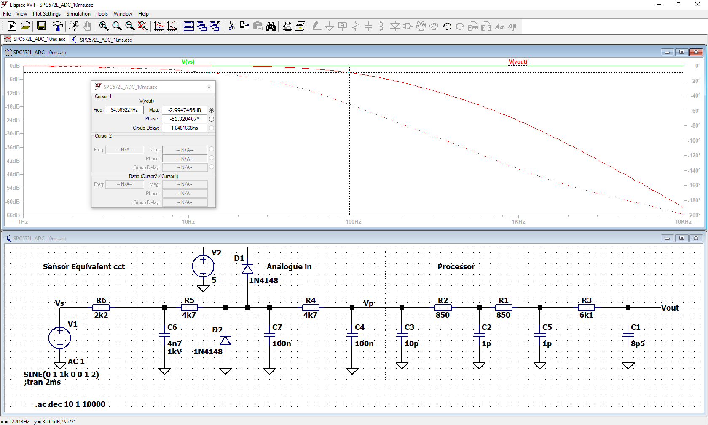

# Leakage Current

Estimate at 150nA at 70C maximum, no injection currents.

150nA * (4k7+4k7+2k2) = 1.74mV

At 10-bits this equals 0.3 * 1 lsb

# Injection Current

Max. Injection current = +/-3m

A diode clamp at R5/C7 with clamp the voltage at that point to Vcc+0.6 or 0V-0.6V. The processor inputs are rated to VCC+0.3V and 0V-0.3V.

Injection current max. = (0.6-0.3)/4700 = 64uA

# Battery Voltage

Battery voltage sensing is a slightly different case because the source impedance is, to all intents and purposes, fixed and very low so a simpler circuit can be used.

# Input Protection

Inputs should be protected against short to battery and short to ground, maximum battery voltage as defined by ISO16750 = 16V, this is not a strenous requirment.

ESD requirements automotive applications are specified by ISO 10605 this is a more strenuous requirement and is much higher than for commercial applications.

## Short to battery

2k2

16-5 = 11

(11*11)/2200 = 55mW

4k7

16 – 5.6V = 10.4V

(10.4*10.4)/4700 = 23mW

Clamp diode

From LTSpice = 1.37mW

## Short to ground

2k2

(5*5)/2200 = 11mW

## ESD

Components very rarely fail completely when subjected to electrostatic discharge. At the higher ESD levels there is usually some degradation of components caused by electrical overstress. ESD protection is designed to reduce the level of degradation to levels that do not affect the working of the ECU. This is difficult to assess from datasheet information, what is presented below is designed from experience.

The 330 pF, 330 Ω test has the highest energy and current of the ISO 10605 standard.

The voltage requirement is between 2kV (contact and air) and 15kV (contact) or 25kV (air). Older ECUs from the 90s would typical be specified at 8kV while ECUs from 2010 onwards would typically be specified at 25kV.

A capacitor on the ECU input acts as a reservoir for the ESD pulse, the value of the capacitor is a compromise between impedance, capacitance and the effect that it will have on the overall circuit characteristics.   
In the circuit illustrated (1ms) bandwidth the 2k pullup is effectively in parallel with the sensor impedance when the ECU is plugged in. The maximum combined impedance will therefore be less than 2k and with the 10nF ESD capacitor the RC time constant is short enough to not affect the operation of the circuit.

A rough calculation of the maximum voltage at the input pin is:

15kV * (330pF/10nF) = 495V

The calculation above does not take into account the energy lost in the energy lost in the 330 Ohm resistor or in the rest of the input circuitry. The Spice simulation below gives a more accurate estimate but does not include any attempt to model stray inductance and capacitance which is shown in the ISO 10605 schematic, however, its not going to make any significant difference to the waveform.

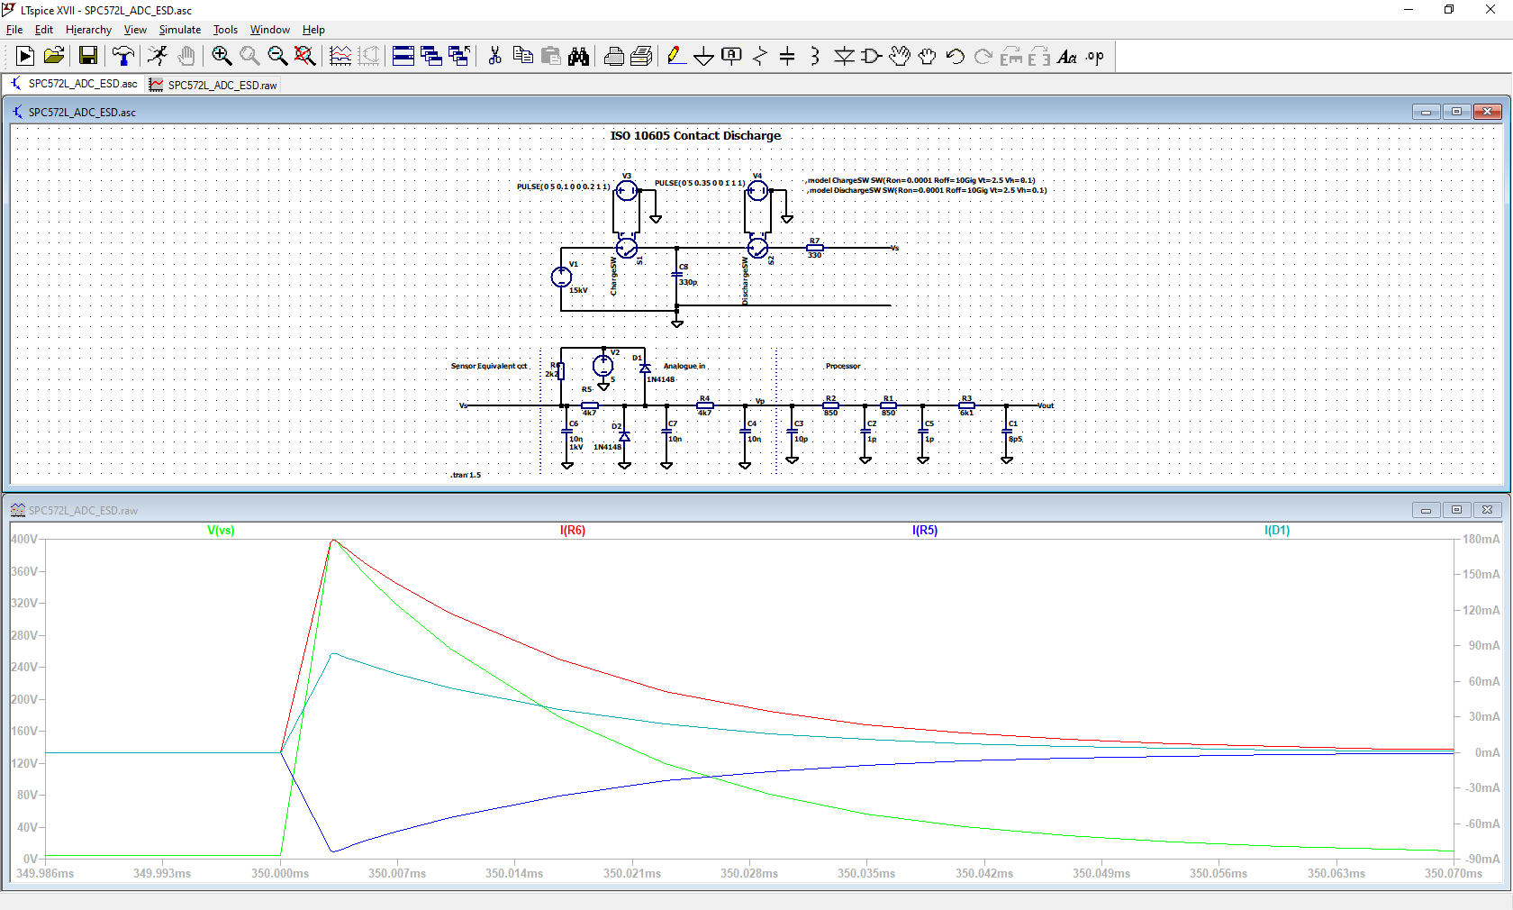

The simulation shows that the peak ESD voltage is reduced to approximately 400V. This allows the use of a 630V or 1kV 1206 sized capacitor. Pulse withstanding resistors must be used for the resistors that are exposed to the higher voltage and power dissipation - a 1206 sized device such as a CRGP1206 is suitable.

The ESD caps need to be located close to the connector with a solid connection to the ground pin or the ECU case with no vias.